Event - Research in Action: Need, Funding, Outcomes
Eastern Regional Forum - Monday 27th February 2023.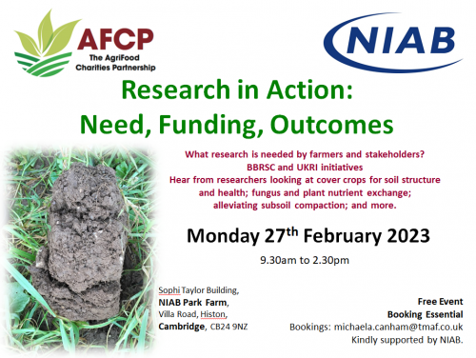
A joint AFCP and NIAB event. Full programme. Speaker Biographies.
What research is needed by farmers and stakeholders?
BBSRC and UKRI Initiatives.
Hear from researchers looking at cover crops for soil structure and health; fungus and plant nutrient exchange; alleviating subsoil compaction; and more.
9.30am to 2.30pm
Sophi Taylor Building, NIAB Park Farm, Villa Road, Histon, Cambridge, CB24 9NZ
Directions.
FREE event
Booking essential. Please email AFCPCoSec@gmail.com including any dietary requirements.

