**The WRO archive - A New Dawn**

*Written by Jim Orson, AFCP Board Member.*

I was amused by an advert for a recently introduced cereal black-grass herbicide product which said it is ‘a new dawn for weed control’. The source of my amusement was that I have been involved with the digitisation of the [Weed Research Organisation (WRO) archive](https://www.bcpc.org/open-access/knowledge-bank) and its uploading onto the [British Crop Production Council (BCPC)](https://www.bcpc.org/) website. This archive includes the results of the glasshouse screening of the active ingredient of this herbicide product in 1986 (WRO Technical report 91 published by Long Ashton Research Station, [part 1](https://www.bcpc.org/view-pdf?pdfurl=83270), [part 2](https://www.bcpc.org/view-pdf?pdfurl=82784)). So, I thought, ‘not so much a new dawn as a long and protracted dawn’.

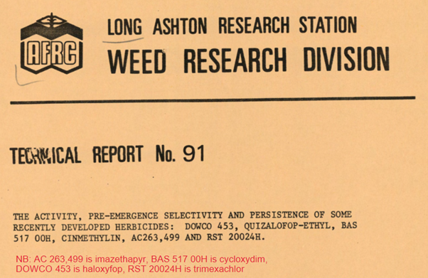

Then I quickly realised that I was being a bit naïve. In the 1980s isoproturon was in its hey-day but the cracks were just beginning to show. In the mid 1980’s herbicide resistance was known to be having a significant impact on the field performance of isoproturon and other herbicides against black-grass on a handful of farms. However, as suspected by some weed scientists and agronomists, this was the ‘tip of the iceberg’. With the benefit of hindsight, it is clear that herbicide resistance was also evolving on fields sprayed regularly against black-grass.

Consequently, in the current resistance and regulatory scenario, manufacturers should be commended for re-evaluating the herbicides in their locker and commercially introducing them where appropriate. Hopefully, easier access to the Weed Research Organisation (WRO) archive will help with this.

**Why digitise?**

On-line searches are now used extensively by scientists and those interested in information on specific subjects. Information and scientific knowledge that is not on-line is far more difficult to access and is often not sought. This can result in much of the valuable scientific data and knowledge that is only available in hard copy being missed. There is also the danger of today’s researchers trying to ‘re-invent the wheel’ at a time when resources in agricultural research are limited. BCPC is striving to prevent this happening and has currently got an [archive](https://www.bcpc.org/open-access/knowledge-bank) of its hugely influential conferences and symposia proceedings in a searchable form on-line, in addition to the new WRO archive. Further on-line archives are contemplated.

You could say these on-line archives are ‘a new dawn for information and data on crop protection’.

**The WRO Archive**

The state-funded WRO opened in 1960 and closed in 1986. Its closure was one of the first acts of a government re-evaluating the state’s role in agricultural research. I have a pet theory of why the WRO was identified for closure. At the time of the decision to close WRO, glyphosate was seen as the final piece of the weed control conundrum. Would the WRO have been closed had the full extent of the future challenge from herbicide resistance been known? Who knows.

The archive contains 111 technical reports published by the Weed Research Organisation and subsequently by the Weed Research Division at Long Ashton Research Station. Many of these present data from glasshouse evaluations on the pre-emergence and the post-emergence activity of individual herbicides on a wide range of temperate and tropical crops and weeds. However, other topics are also covered in the technical reports e.g. aquatic weed control, weed surveys, methods for analysis of herbicides, methods for determining effects of herbicides on microorganisms, growing weeds from seeds for experimental purposes, amenity weed control, effects of herbicides on field margin flora etc.

Ten WRO annual/biennial reports, covering 1960 – 1983, have also been digitised and these include articles on a wide range of weed-related topics. Many of these are well worth reading as they are still very relevant today and contain valuable well researched information. These articles also list key reference material that still may only exist in hard copy. In addition, the archive also contains an authoritative 296-page book ‘[Wild-oats in World Agriculture](https://www.bcpc.org/view-pdf?pdfurl=84019)’ which was written largely by WRO staff and published in 1976.

These publications are now, for the first time, available and searchable online following digitisation arranged by BCPC with funding from the [Chadacre Agricultural Trust](https://www.chadacre-trust.org.uk/), the [Felix Thornley Cobbold Agricultural Trust](https://www.felixcobboldtrust.org.uk/), the [Perry Foundation](https://www.perryfoundation.co.uk/), the [Douglas Bomford Trust](https://www.dbt.org.uk/), and [The Morley Agricultural Foundation](https://tmaf.co.uk/) co-ordinated by the [AgriFood Charities Partnership](https://www.afcp.org.uk/) (AFCP). Much of the information is still very relevant, such as reviews on the factors affecting the activity of herbicides and many of the herbicides evaluated are still widely used globally. It is worth anyone interested in weed control seeing what independent research was done at the WRO and its interpretation of the results.

***To find the WRO archive go to*** [***BCPC.org***](https://www.bcpc.org/)***, click on Open Access, then*** [***Knowledge Bank***](https://www.bcpc.org/open-access/knowledge-bank) ***and select the tab ‘WRO Reports’.***



