Three things I learned about achieving net zero through on-farm carbon assessment

Wing Kwan Pauline Ng is a PhD Student in the Department of Animal and Agriculture, Hartpury University, studying achieving Net Zero through farm level audits on commercial farms, funded by AFCP member, the Douglas Bomford Trust and the John Oldacre Trust.

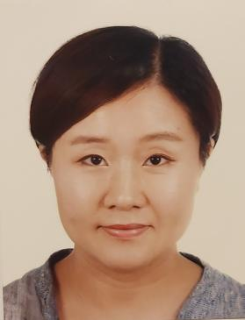

Wing explains: There has been limited use of real-time field analysis tools to measure, track and verify soil organic carbon (SOC) levels on farms to assess soil changes. These could aid farmers’ management. Therefore, my work is exploring how available carbon accounting tools and measurement techniques can be implemented on farms to enhance carbon assessment and mitigation options. To do this there are four main objectives:

- To identify areas and strategies for refining on-farm measurements;
- To perform on-farm carbon assessment;
- To evaluate use of existing carbon measurement tools; and
- To identify possible mitigation options to reduce carbon emissions for climate change alleviation.

Research so far…

Field work was carried out in March 2023 in rain, snow and sunshine. Soil and forage samples were collected at Hartpury Home Farm (HF) with 5 soil and 5 forage samples taken in random points walked in a ‘W’ pattern across 70 fields (Figure 1). Mobile near-infrared reflectance spectroscopy (NIRS) was used to obtained real-time soil and plant nutrient measurements (Figure 2). The soil properties of (1) Soil Organic Carbon (SOC), (2) total nitrogen, and (3) clay were obtained from the analysis.

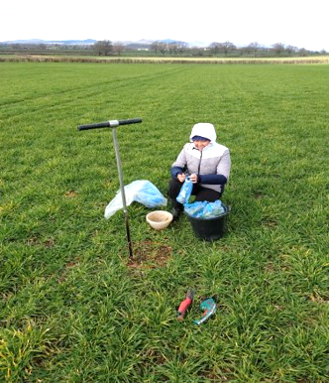
Soils were assessed using thresholds for SOC/Clay ratio of 1/8, 1/10 and 1/13 to indicate the boundaries between ‘very good’, ‘good’, ‘need improvement’ and ‘poor’ respectively (Table 1). On this scale, soil samples of arable and temporary ley fields had a higher % of SOC/Clay ratio within poor or suggest improvement thresholds compared to permanent and woodland areas with a higher % of good or very good SOC/Clay ratio after NIRS analysis (Table 1). Although arable and temporary ley fields were more productive with a greater herbage height and cover than permanent grass (PG) fields, PG fields had significantly better SOC and nitrogen levels (Table 2).

Figure 1: (a) left: Field sampling in an arable field; (b) right: Field sampling woodland area.

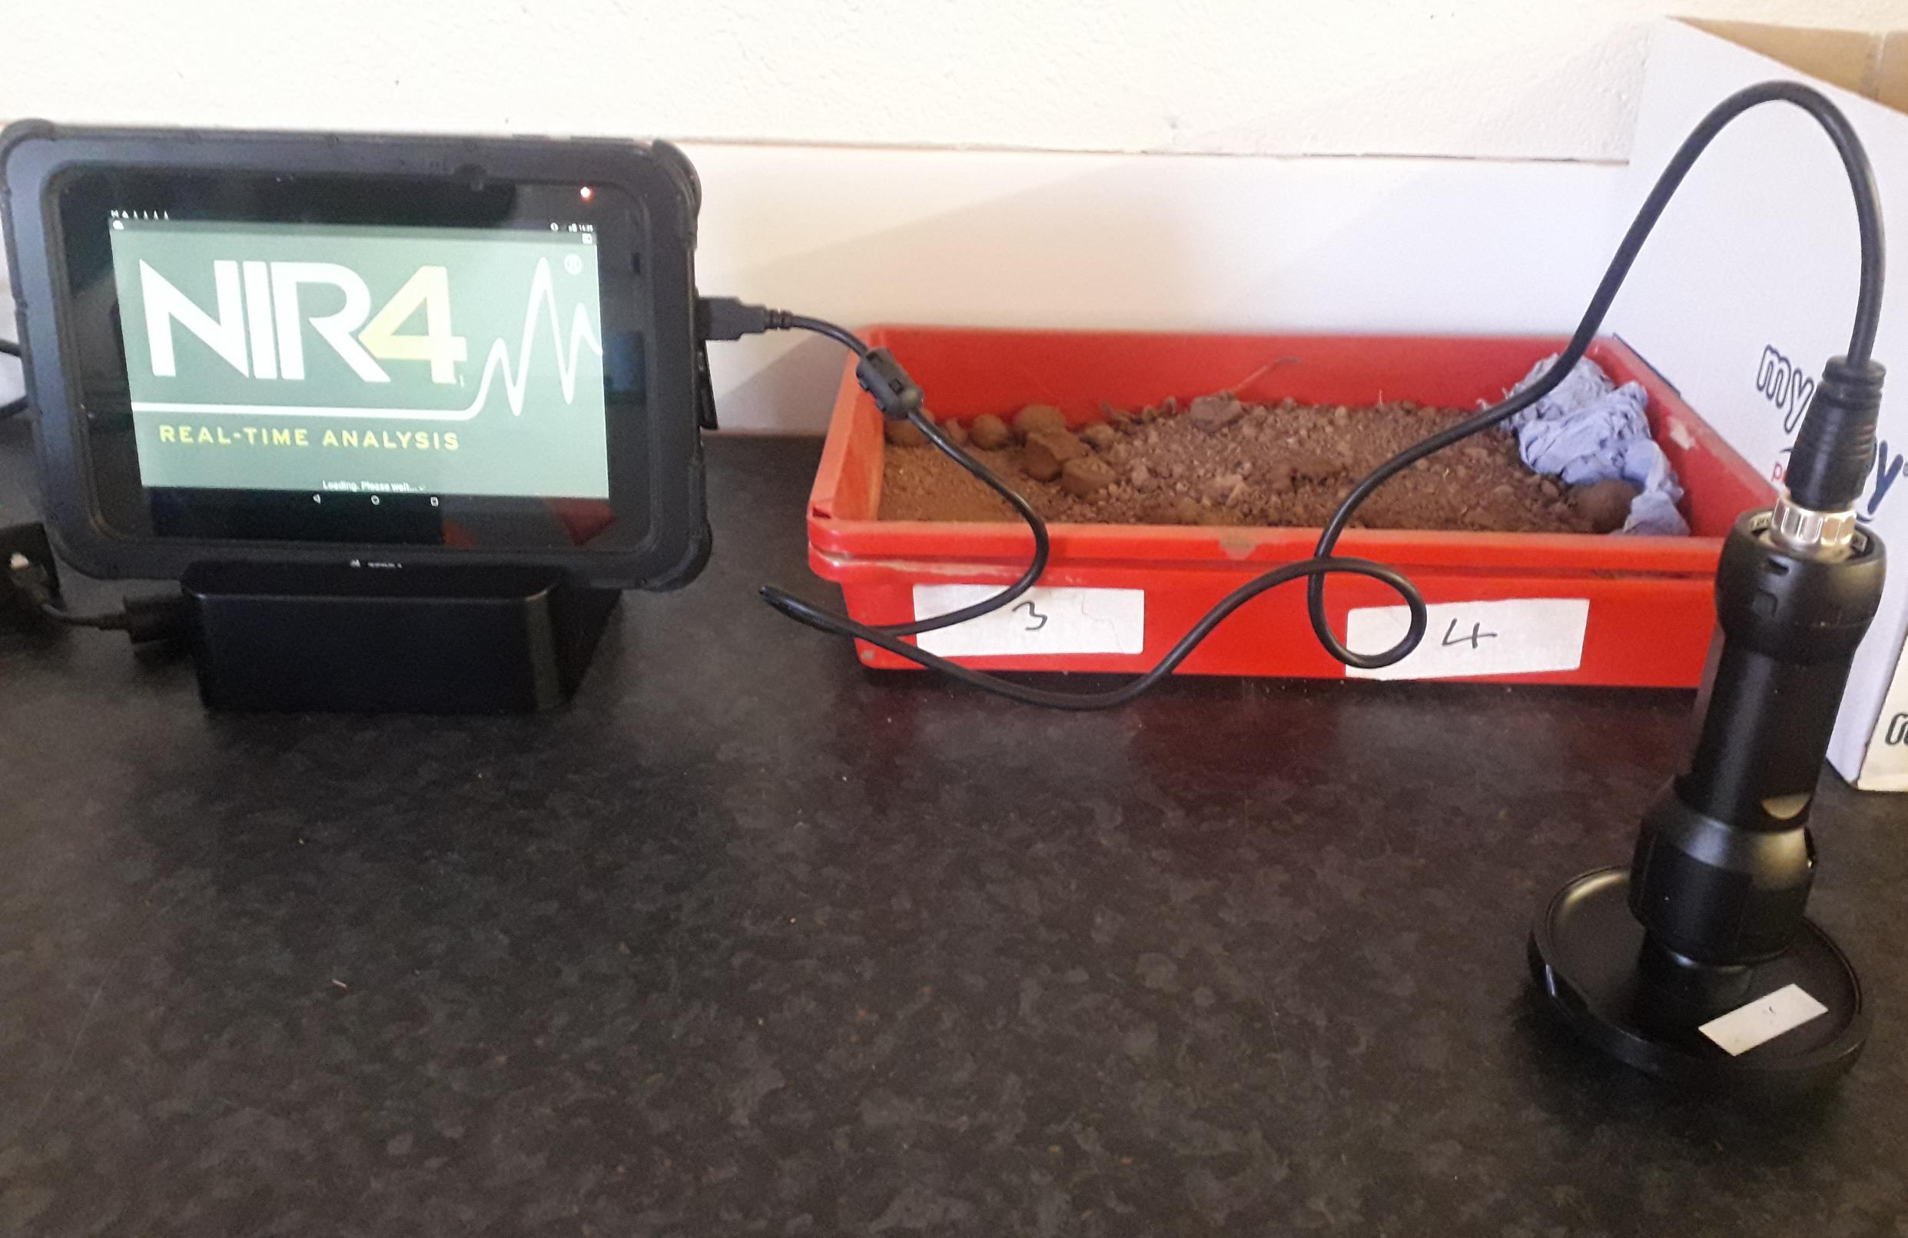
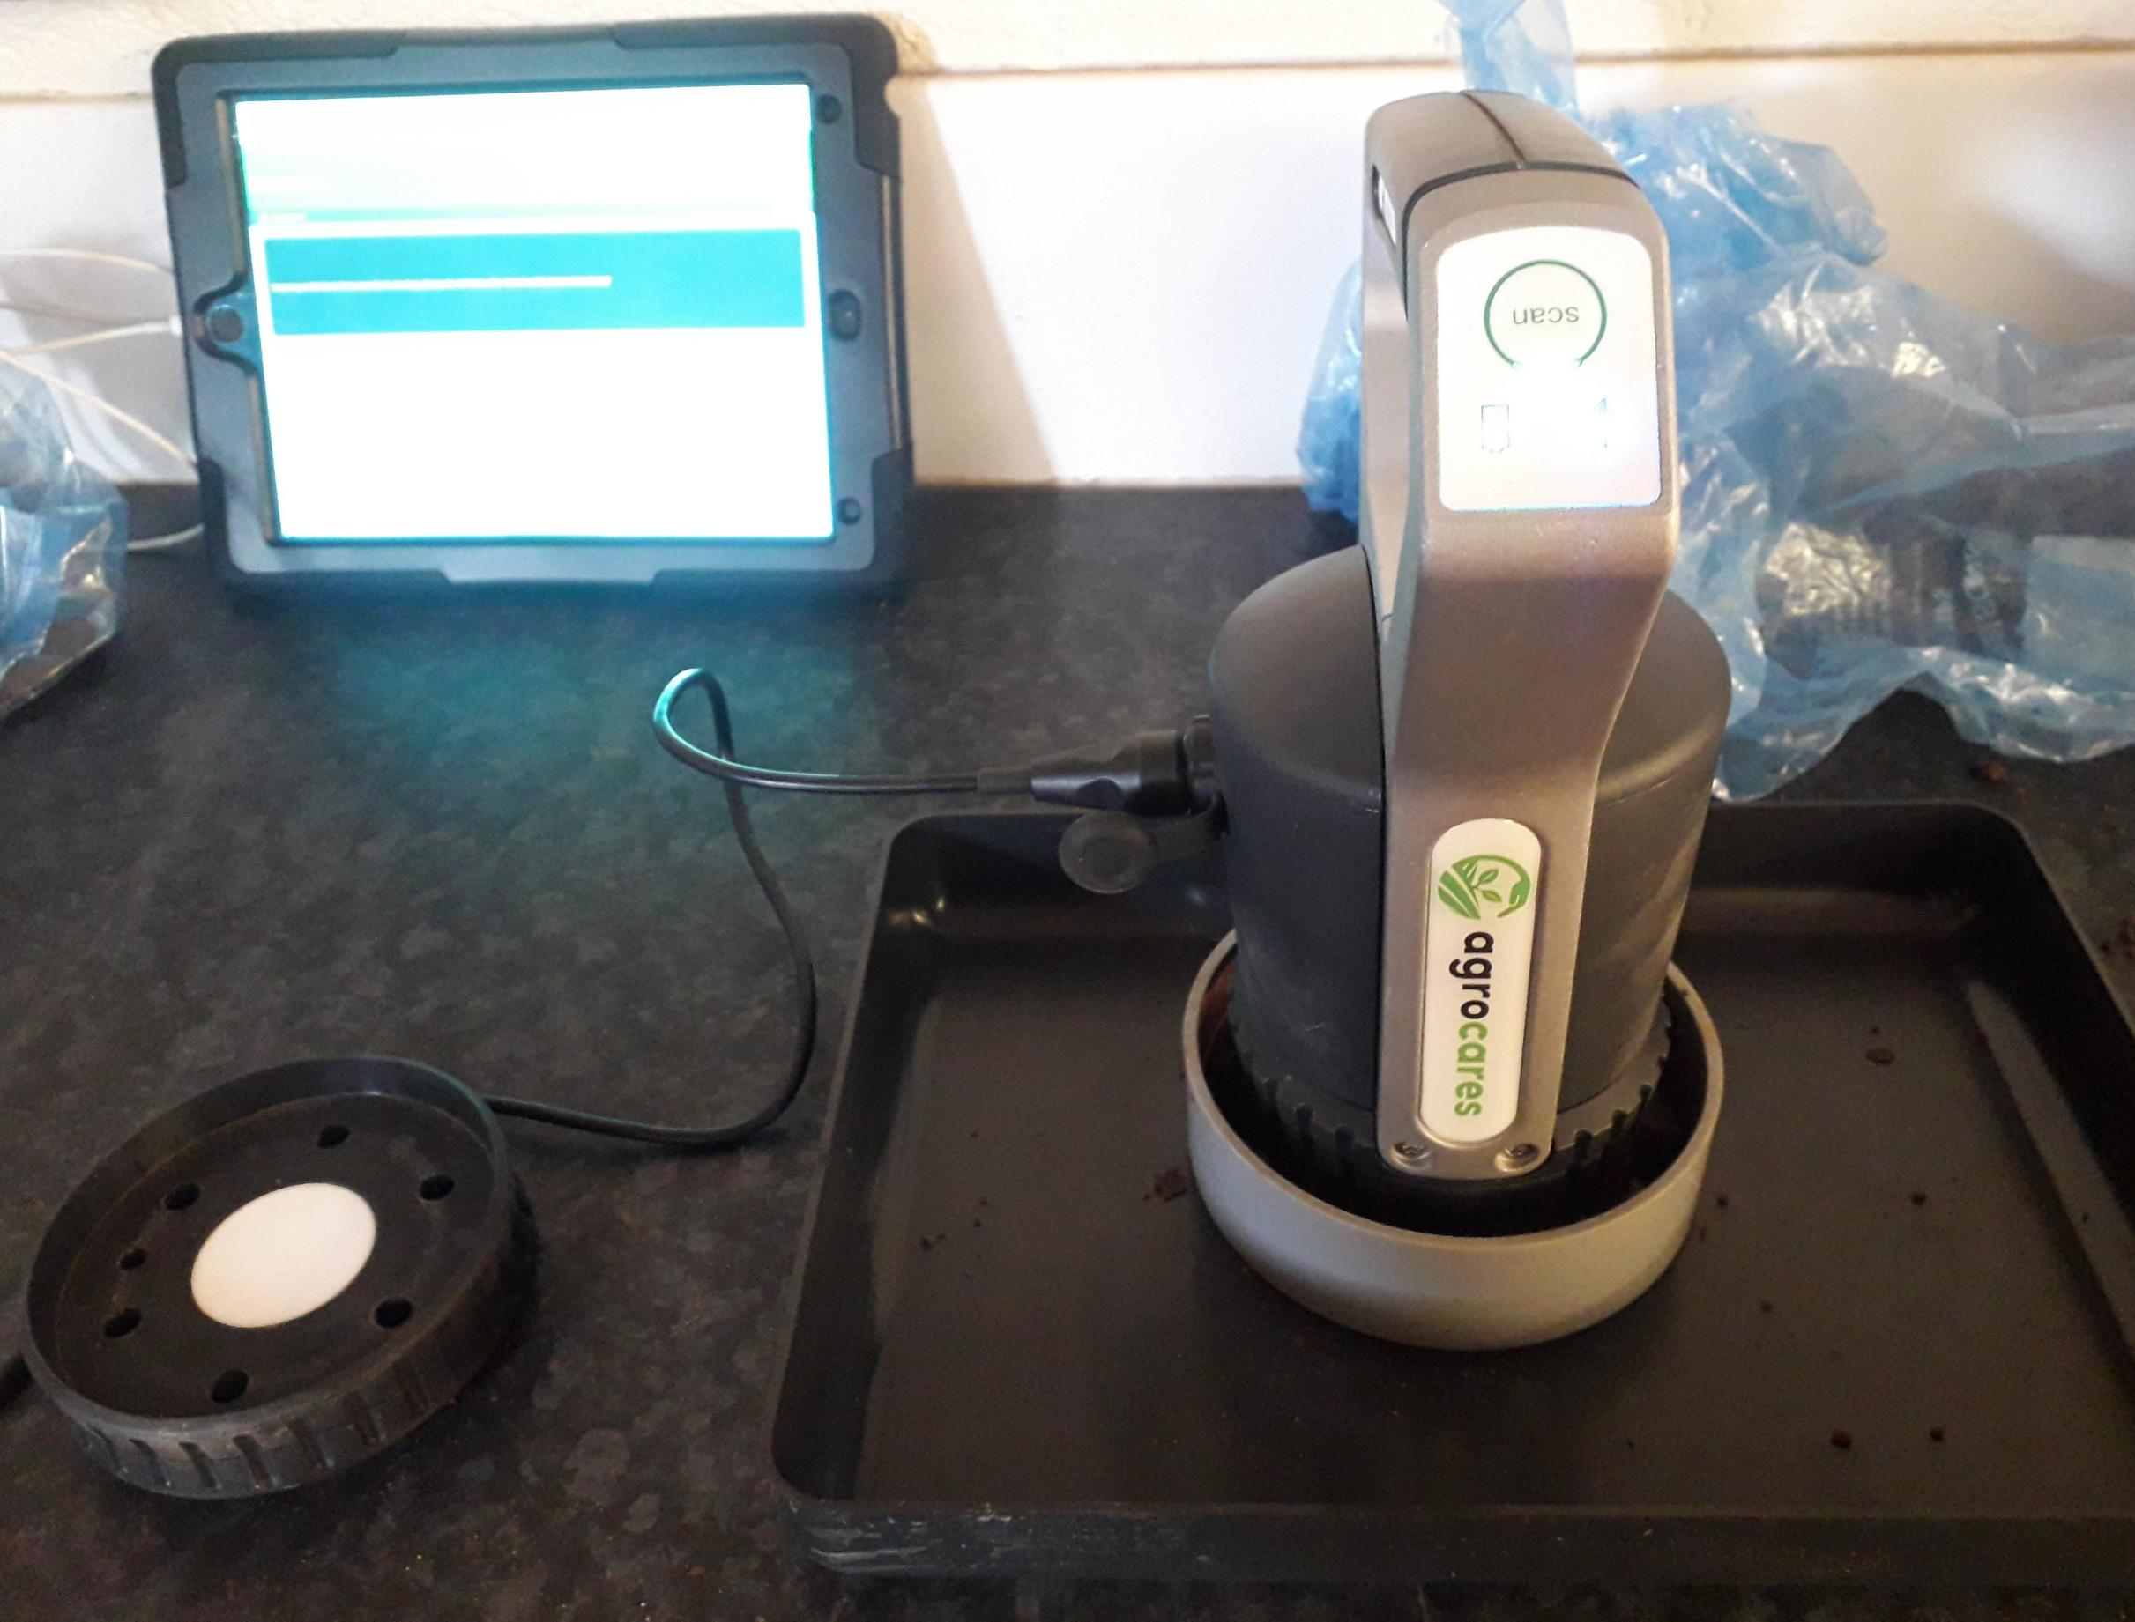

Figure 2: left: (a) Agrocares soil scanner; right: (b) NIR4 forage scanner for real-time nutrient analysis

Table 1: Percentage of fields with SOC/Clay thresholds of 1/8, 1/10, and 1/13 for each land type studied
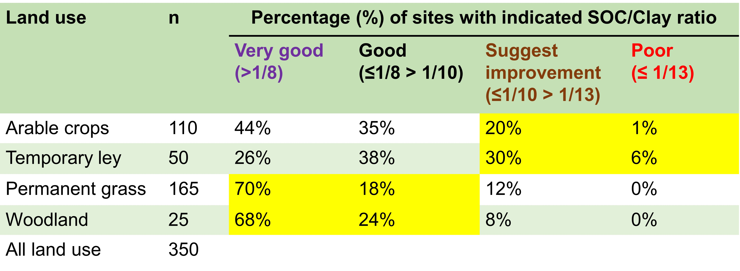

Table 2: Predicted mean (s.e.) soil and plant herbage nutrients (FW = Fresh Weight, DM = Dry Matter)
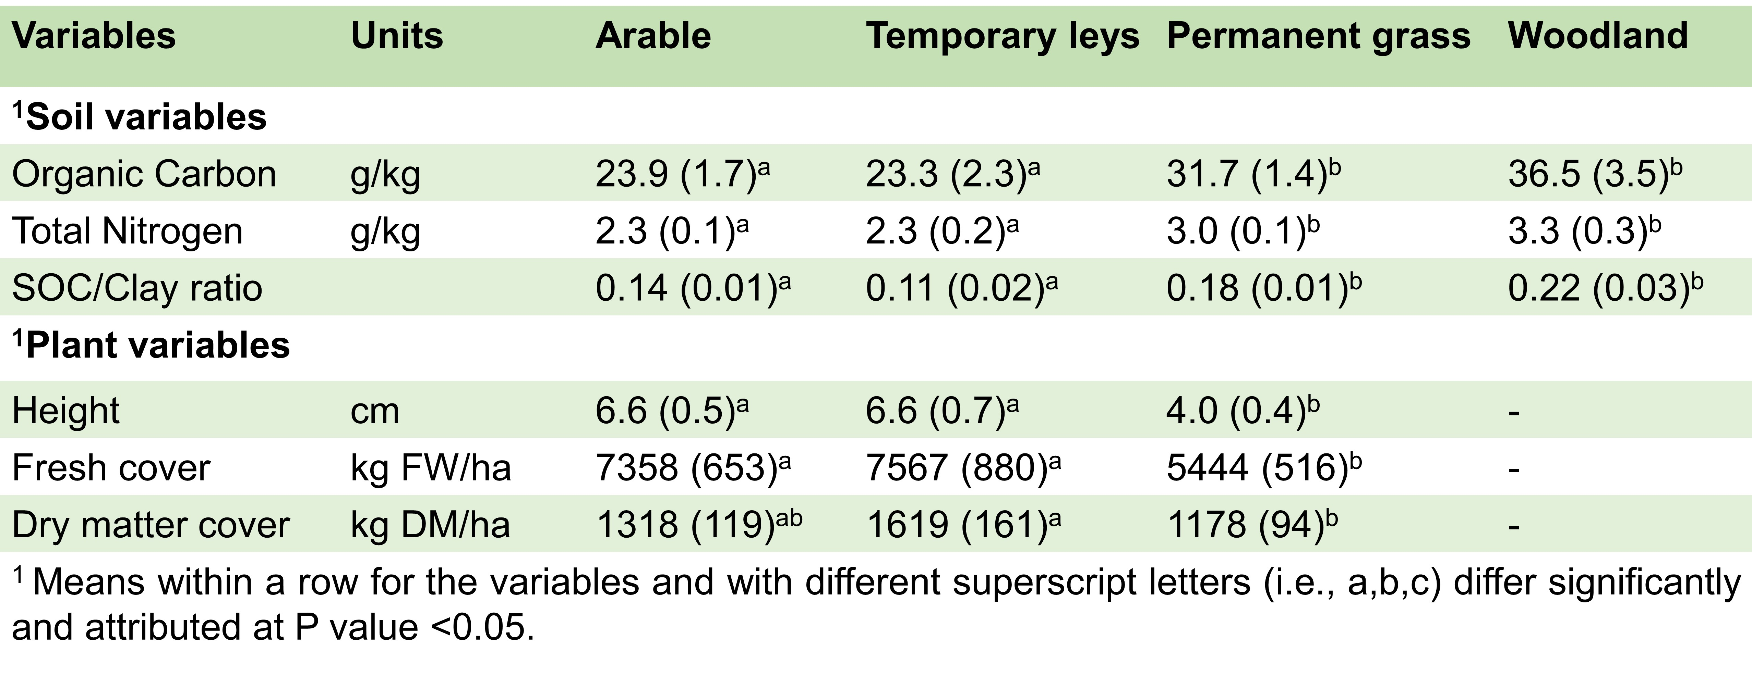

Initial findings

From the field work on HF in March, I learned that planning the work beforehand was never an easy task. It really depended very much on the weather, the actual environmental conditions on the fields (e.g. we had experienced some strong wind with snow when sampling), as well as the equipment on hand also. I nearly ran out of sampling bags and battery of the electric grass cutter, but it was so fortunate and blessed that my professors did bring along with him a few extra bags together with a big manual scissors, so that we could finally manage to collect all the required samples, and brought them back to Hartpury laboratory for the NIRS analysis. That was really an unforgettable and precious field experience to me ever! Further, the overall results indicated that there was a considerable variation in the SOC content across fields and differences among land uses of HF. This study overall shows that NIRS can serve as a user-friendly and practical alternative for initial and effective real-time field measurements to indicate critical soil and plant variability among land use types. However, further work is needed to evaluate confidence levels on such technique to support monitoring among different land uses and to improve on-farm carbon assessment in the near future.

Acknowledgment

We are grateful to the John Oldacre Trust and The Douglas Bomford Trust for funding this PhD studentship.

Supervisors

Prof. Matt Bell (Hartpury), Dr Day Teixeira (Hartpury), Dr Adrian Crew (UWE Bristol), Dr Pete Maxfield (UWE Bristol)

