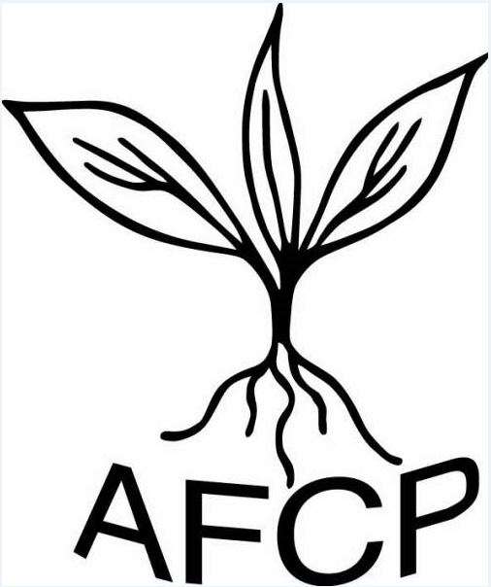 AgriFood Charities Partnership (AFCP)
www.afcp.org.uk

Charities have a big role to play in upskilling the agri-food industry

The charities spanning the food and farming industry have a big role to play in supporting the industry to deliver new technical and business skills, as well as training, according to speakers at the 9th annual forum in London on ‘where charities should focus on upskilling agriculture and the food industry.’

The forum acknowledged that as Britain leaves Europe, the food and farming industry faces unprecedented challenges, and opportunities, that require more collaboration between charities and the industry than ever before.

Greater communication, sharing resource and intelligence must be central to AFCP’s remit in order to drive the education, research and behavior changes needed for an economic and environmentally sustainable food and farming sector, according to AFCP’s new CEO Debbie Beaton.

“More effective collaboration is essential to deliver an industry that can compete globally. The industry must set the direction and lead, but the charitable sector which spans more than 150 organisations and a collective pot of £3.5m can play a significant part,” she said.

“I hope that, during my time in this office, I can build on the great work that Paul Biscoe has done in bringing charities together to support common objectives – and forging even stronger relationships with the AHDB, NLBC and others to deliver unique research and learning.”

Echoing that call for collaboration, Sarah Purdell, programme manager with the National Land Based College, which was set up last April to champion skills and learning for the industry, revealed her intent to deliver a collaborative initiative with ARTIS, managed by NIAB, to broaden the reach of their high quality training programmes in crop protection with colleges and farmers.
She also believed that AFCP and its member charities could play a critical bridge with the NLBC: “Matching the right people to the right skills will be crucial to our success and whilst the NLBC will be the drive behind the courses, we will look to the charity sector to play a key role in funding the development of new training materials to better suit the needs of employers, as well as funding individuals for the training. And by broadening the training on offer to others it will, in turn, bring down the cost of training and hopefully give charities more return on their investment.”

NOTES TO EDITORS

The, AFCP Annual Forum Upskilling agriculture and food supply—where should charities focus? took place on Wednesday, 23rd November 2016 at the SCOPE, 6 Market Road, London N7 9PW. Full speaker line up on the AFCP website www.afcp.org.uk

The Agri-Food Charities Partnership (AFCP) was created in 2008 to help to guide, and build, greater impact from the charities spanning the agri-food sector.
AFCP’s overall aim is to help identify appropriate collaborations and partnerships with other charities, colleges and universities, research organisations, industry and Government in order to make best use of funds and deliver the greatest impact in education, skills and research.
AHDB – The Agricultural and Horticultural Development Board collects a statutory board with levies collected from farmers, growers and the processors to equip levy payers with independent, evidence-based information and advice. www.ahdb.org.uk
NLBC – The National Land-Based College is working with existing industry groups to help steer skills development across the land based sector which will include working with City and Guilds to develop new qualifications, establishing an online register of land based learners and promoting continued professional development.
STEM – Science, Technology, Engineering and Mathematics in education College will look to work with existing initiatives, add value and stimulate the development of new joint working, collaborations and p

